1] image acquisition and representation

Code :

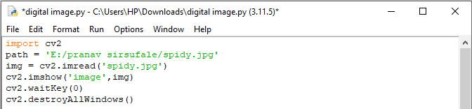

**OUTPUT:**

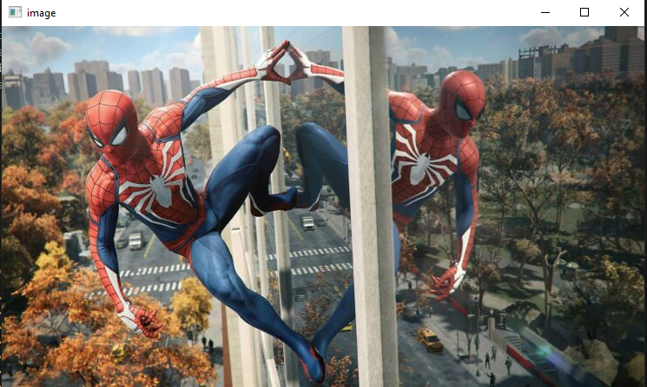

2] image compression and storage.

Code :

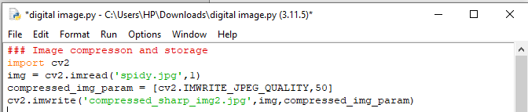

OUTPUT:

|  |  |
| --- | --- |
| ORIGINAL IMAGE | COMPRESSED IMAGE |

3] image filtering and Restoration – Spatial domain filtering, Frequency domain filtering Image denoising and restoration.

Code :

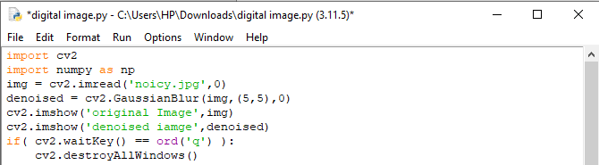

OUTPUT:

|  |  |
| --- | --- |
| ORIGINAL IMAGE | DENOISED IMAGE |

4] Convert bright image into dark image.

Code :

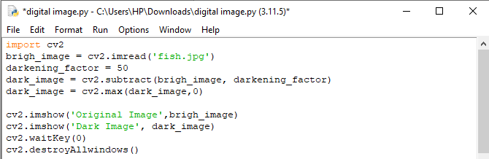

OUTPUT :

|  |  |
| --- | --- |
| ORIGINAL IMAGE | DARK IMAGE |

5] Convert dark image into bright image.

Code :

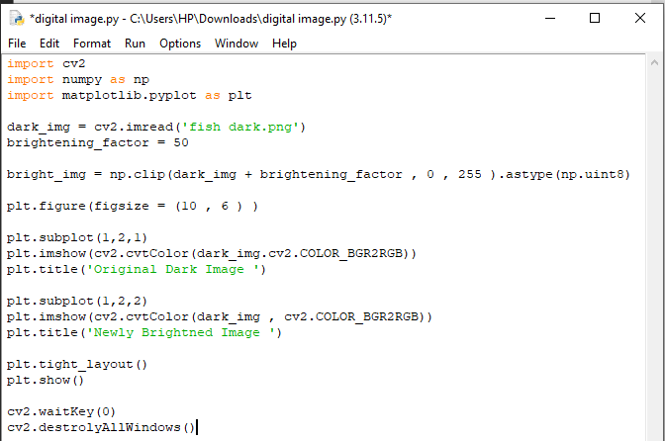

OUTPUT :

|  |  |
| --- | --- |
| ORIGINAL DARK IMAGE | NEWLY BRIGHTED IMAGE |

6] Take an image and apply Gaussian blur filter on it to sharp the image.

Code :

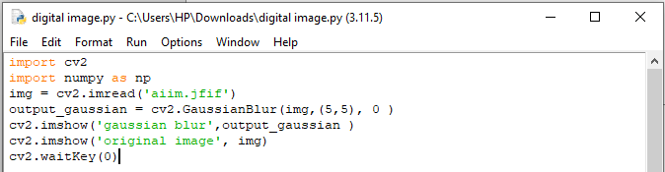

OUTPUT :

|  |  |
| --- | --- |
| ORIGINAL IMAGE | GAUSSIAN BLURED IMAGE |

7] Take an image and apply medium blur filter on it.

Code :

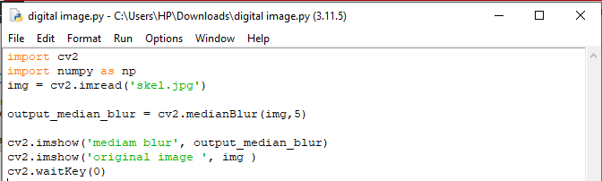

OUTPUT :

|  |  |
| --- | --- |
| ORIGINAL IMAGE | MEDIUM BLUR |

8] Take an image and apply bilateral filter on it.

Code :

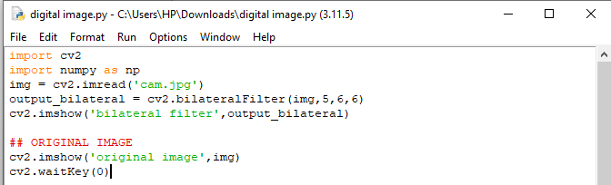

OUTPUT :

|  |  |
| --- | --- |
| ORIGINAL IMAGE | BILATERAL FILTERED IMAGE |

9] Write a program to show only horizontal feature using sobel operator.

Code :

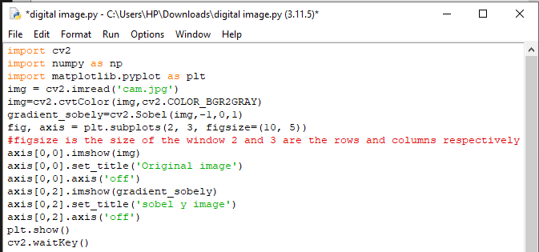

OUTPUT :

|  |  |
| --- | --- |
| ORIGINAL IMAGE | SOBEL Y IMAGE |

10] Write a program to show only vertical feature using sobel operator.

Code :

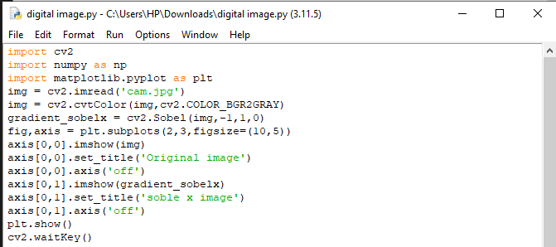

OUTPUT :

|  |  |
| --- | --- |
|  |  |

11] Write a program to apply laplacian filter on an image.

Code :

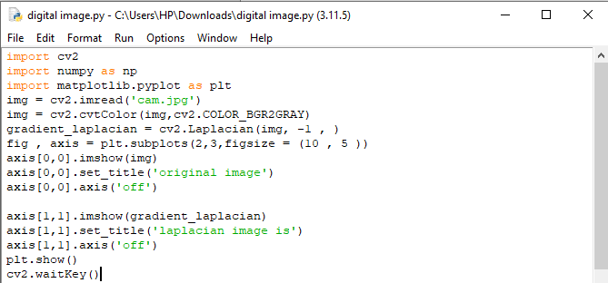

OUTPUT :

|  |  |
| --- | --- |
|  |  |

12] Write a program to draw a histogram of an image.

Code :

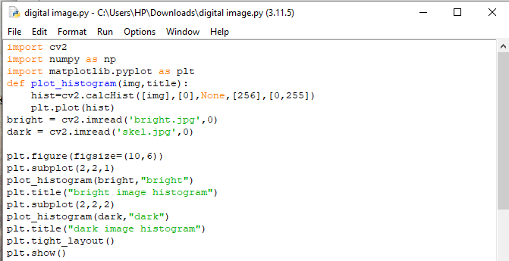

OUTPUT :

|  |  |
| --- | --- |
|  |  |

13] Write a program to apply thresholding on an image and show the threshold output.

Code :

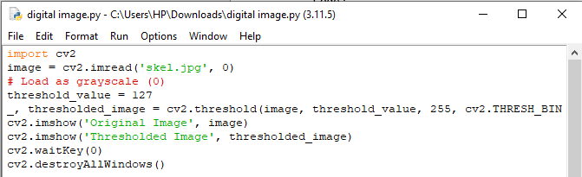

OUTPUT :

|  |  |
| --- | --- |
| ORIGINAL IMAGE | THRESHOLDED IMAGE |